TASK 1
Here are some online activities in order to learn and / or practise the verb “TO BE” and “TO HAVE”.
The Verb TO BE – Simple Present
- Easy English (2015, Diciembre 5). The verb "TO BE" - Simple Present - Easy English Class [Archivo de video] Recuperado de: https://www.youtube.com/watch?v=co6lmoOoZsU&t=4s

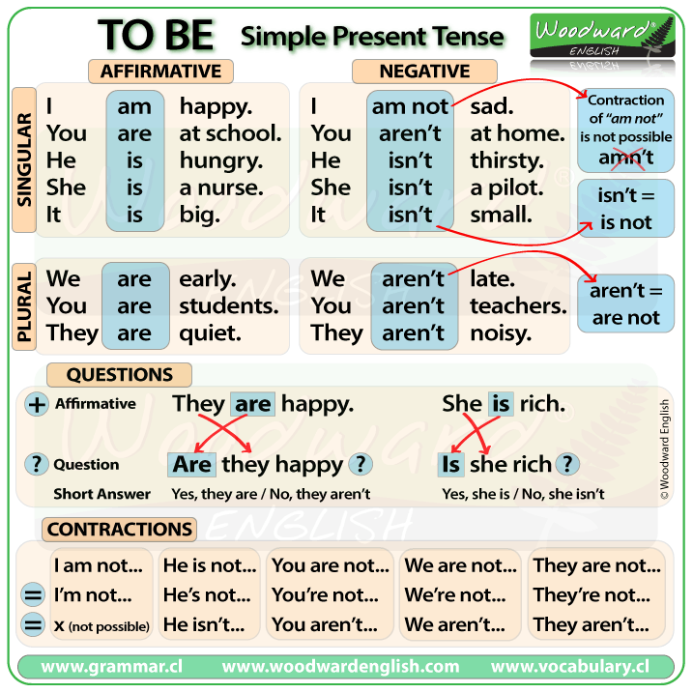
TO BE – Simple Present Tense
- Recuperado de: https://www.pinterest.de/pin/568860996675513328/

Superprof – Material Didáctico – Verb Tense
Recuperado de: https://www.superprof.es/apuntes/idiomas/ingles/gramatica-inglesa/verb-tense/

TO BE – Practice
- Affirmative Form
https://www.superprof.es/apuntes/idiomas/ingles/gramatica-inglesa/verbs/exercises-to-be-simple-present.html
- Negative Form
https://www.superprof.es/apuntes/idiomas/ingles/gramatica-inglesa/verbs/exercises-to-be-simple-present-negative.html
- Interrogative Form
https://www.superprof.es/apuntes/idiomas/ingles/gramatica-inglesa/verbs/exercises-to-be-simple-present-interrogative.html

The Verb TO HAVE – Present Simple

Easy English (2015, Diciembre 5) The verb "TO HAVE" - Simple Present - Easy English Class [Archivo de video] Recuperado de: https://www.youtube.com/watch?v=7Mi8KHU91EI

Verb 'To have': simple present affirmative
https://www.superprof.es/apuntes/idiomas/ingles/gramatica-inglesa/verbs/verb-to-have-simple-present-affirmative.html
TO HAVE – Practice
- Affirmative Form
https://www.superprof.es/apuntes/idiomas/ingles/gramatica-inglesa/verbs/exercises-to-have-simple-present-affimative.html

- Negative Form
https://www.superprof.es/apuntes/idiomas/ingles/gramatica-inglesa/verbs/exercises-to-have-simple-present-negative.html

- Interrogative Form
https://www.superprof.es/apuntes/idiomas/ingles/gramatica-inglesa/verbs/exercises-to-have-simple-present-interrogative.html

The Indefinite Article
- Exercise 1: https://www.curso-ingles.com/practicar/ejercicios/the-indefinite-article
- Exercise 2: https://www.curso-ingles.com/practicar/ejercicios/the-indefinite-article-2
Unit Test: https://www.curso-ingles.com/practicar/ejercicios/the-indefinite-article-2

